ME-Bactria-Margiana-seated female figure

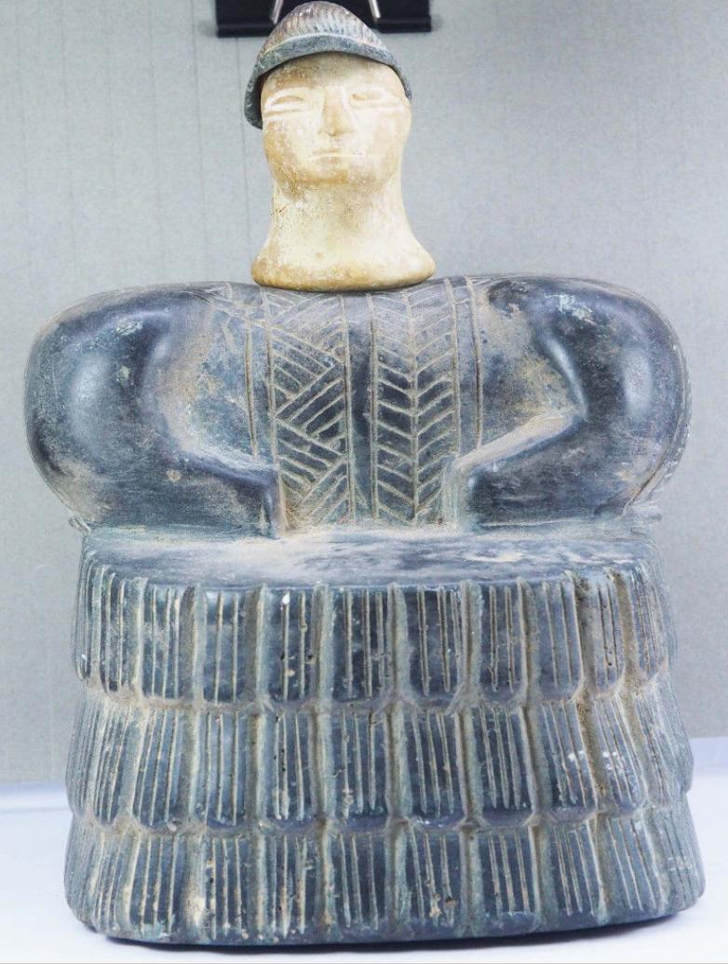 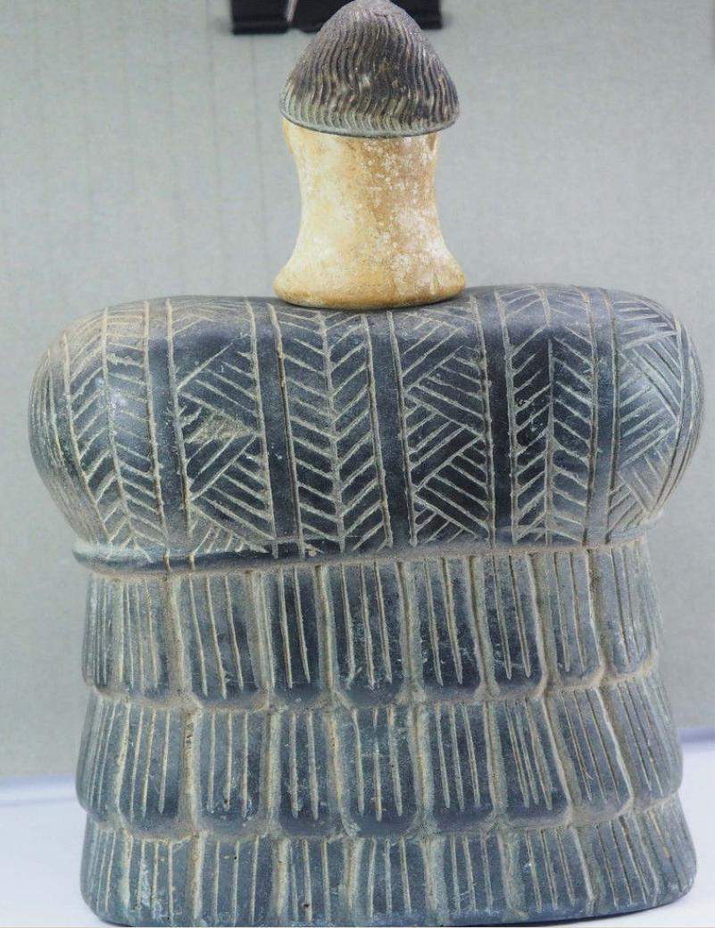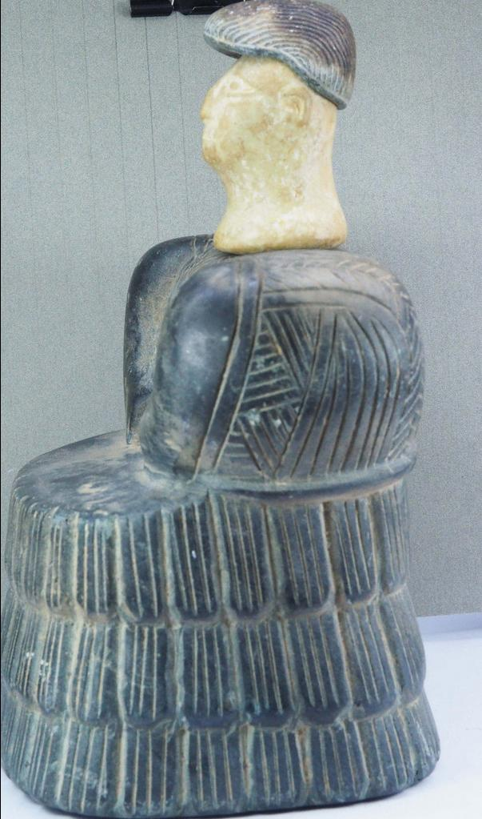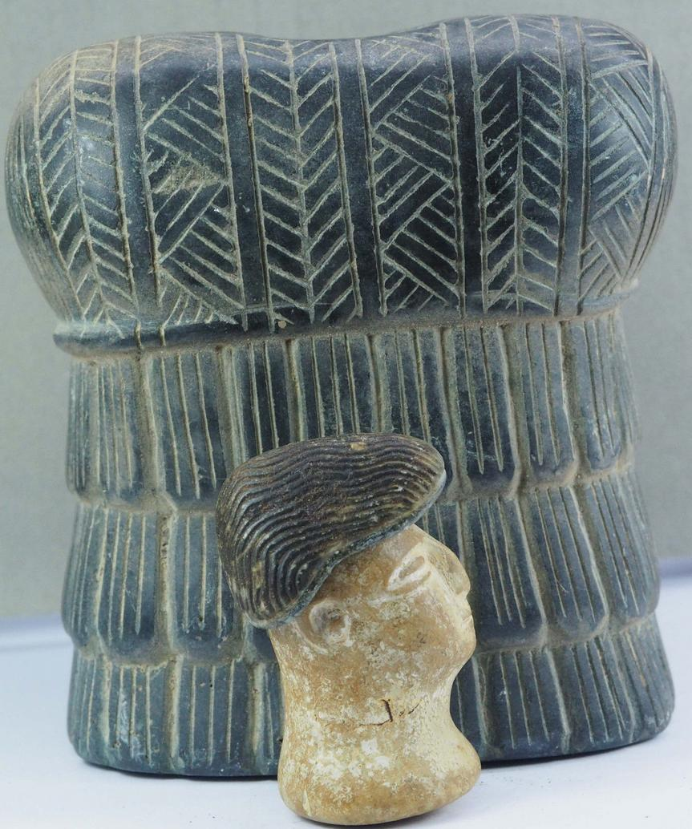

Formal Label: Bactria-Margiana composite chlorite and white calcite seated female with chlorite cap, Middle to Late Bronze Age, 2000-1650 BCE

Accession Number: GN778.32.A4

Date or Time Horizon: Middle to Late Bronze Age, 2000-1650 BCE

Geographical Area: Afghanistan

Cultural Affiliation: BMAC (Oxus)

Media: composite chlorite and white calcite

Dimensions: H 2 5/8 in

Weight:

Provenance: [vintage.intaglio](http://myworld.ebay.com/vintage.intaglio), Thailand

**Discussion:**

Sold by [vintage.intaglio](http://myworld.ebay.com/vintage.intaglio) ( [457](http://feedback.ebay.com/ws/eBayISAPI.dll?ViewFeedback&userid=vintage.intaglio) )

Estimated delivery Friday, Dec 23, 2016 - Tuesday, Jan 10, 2017

#### [ROYAL EMPEROR OLD RARE BACTRIAN COMPOSITE STONE IDOL FIGURE # k](http://www.ebay.com/itm/282280904314)

|  |  |
| --- | --- |
| Item price | $570.00 |
| Quantity | 1 |
| Item number | 282280904314 |
| Shipping service | Economy Shipping from outside US |

#### [RARE ANCIENT BACTRIAN 3 IDOL WORSHIP FIGURES STONE STATUE](http://www.ebay.com/itm/282280912207)

|  |  |
| --- | --- |
| Item price | $315.00 |
| Quantity | 1 |
| Item number | 282280912207 |
| Shipping service | Economy Shipping from outside US |

#### [BACTRIAN RARE ANCIENT IDOL FIGURE STONE STATUE](http://www.ebay.com/itm/282280913804)

|  |  |
| --- | --- |
| Item price | $290.00 |
| Quantity | 1 |
| Item number | 282280913804 |
| Shipping service | Economy Shipping from outside US |

## Shipping address

Ralph J Coffman Jr

149 Atlantic Ave

Swampscott MA 01907-2427

United States

## Order total

|  |  |
| --- | --- |
| Subtotal | $1,513.90 |
| Shipping | $27.00 |

**Total**

$1,540.90